﻿

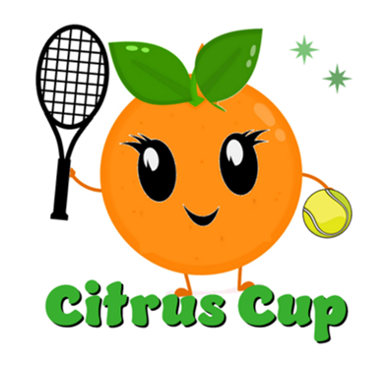

Save the Date

Citrus Cup 2027 is February 18-21, 2027
The Lottery date is July 1, 2026
*see below for additional information

How to Register for Citrus Cup 2027
H
One person (captain) from your team will send me an email on July 1st before 5pm requesting a spot in the 3.5/4.0 division.
- The following information MUST be included:
- "I have a 3.5/4.0 team and I have read the information regarding team composition etc"
- Team's City and State
- Team Captain’s Name, Email and Phone Number
- Team Name if you want to reserve it
- Team Song if you want to reserve it

If more than one person from your team sends the request to register, the team will be disqualified for 2027. Please do NOT send an email before July 1st.

Each team will be entered into a drawing (lottery). All teams will be notified by July 10th. Teams not selected will be added to a wait list. Teams that are selected will be provided with next steps.

________________________________________________________________

About Citrus Cup:
Citrus Cup is a women’s doubles tournament. Its competitive but more importantly, its for fun and friendship!
- There is a no grump, no grouch and no complain rule...smiles, energy and cheering are rewarded!
- Teams consist of 4 to 6 players (see division rules below)
- Your team plays 9 ten game pro sets over 3 days
- Space is limited to 10 teams in each division.
- Citrus Cup is on clay courts
- Players must be over 40 years of age (unless prior approval by coordinator)

Divisions:
- 2027 Citrus Cup will be comprised of 3.5/4.0 division only:
- Teams are a minimum of 4 and a maximum of 6 players.It is recommended that teams bring a total of 5 to 6 players.
- There will be 4 players on the courts at one time.
- ONE 4.0 player (or a 3.5 player) may be on court 1 with a 3.5 player
- ONE 4.0 player (or a 3.5 player) may be on court 2 with a 3.5 player
- There will NOT be a prize awarded for pure 3.5.
- Pure 4.0 teams are not allowed.

Location:
Saddlebrook is a resort offering lodging, golf, tennis, restaurants, spa and pool.
Click Here to Learn More

Date:
Thursday, February 18 - Sunday, February 21, 2027
- Welcome Event is February 18th at 5:30pm.
- This is a mandatory event for captains AND players.
- It's a fun event with teams wearing outfits that reflect their team theme/name. Event will include food, fun, dancing, music and cash bar.
- Play is Friday, Saturday and Sunday.
- Teams receive their play schedule at the Welcome Event on Thursday.
- Following play on Sunday, we will end with a short awards ceremony. After the ceremony, I invite all teams to join me at the pool area for relaxation and fun.
- Most teams head back home on Monday morning.

Cost:
- Cost is $195 per player. The $195 covers 3 days of match play, welcome event, court time, balls, lunch on Friday and lunch on Saturday.
- Accommodations and travel are up to you and at your expense.
- Saddlebrook Resort will provide Citrus Cup lodging prices; a link to options and associated discounts will be sent to registered teams.

Player Ratings:
- Every player should rate as follows - when in doubt, call me.
- Use USTA rating IF you are currently playing USTA
- If your level of play is higher than your USTA rating, use level of play rating.
- I understand your desire to be competitive but please, be fair first! When in doubt, challenge yourself and play up.
- Do not sandbag - if it becomes obvious at the tournament, you won't be eligible for future Gourmet Cups.

Awards:
- Very small prizes awarded...
- The Welcome Dinner "GREATfruit" Award: Its all about the Welcome Dinner! Teams come dressed to represent their team name. T-shirts/costumes, creativity, energy; its about having fun! Every team that participates in the "GREATfruit" Award will begin the tournament with 4 points.
- The "Floridian" Award: This award will be given by the tournament coordinator, to the team with the best costumes on Thursday night.
- First Place in Points (games won + bonus points).
- ﻿The "Sunshine" Award: On the final day of play, teams will vote for the team that best demonstrated fun, team spirit and sportsmanship.

Holly Matson
hollymatsonfl@gmail.com
206-255-6766



