
Kicking off the Overseas Cup Tours…
Tennis and Gorillas in Kigali, Rwanda, Africa!
August 24 – 26, 2026 - Tennis exchange with excellent local players . Local excursions, based on recommendations of Jason Benedict, our experienced organizer, and his contacts.
The plan in Kigali:
Start each morning at the hotel with breakfast before tennis. Take the shuttle van to the courts at IPRC Kicukiro Ecology Tennis Club. Play a round-robin tournament under the usual Gourmet Cups format with the local tennis pro, Kevis, and his hand-picked local athletes. Fun and laughter, with prizes on the last day.
 | Monday | Tuesday | Wednesday | Thu | Fri | Sat
Morning | Tennis | Tennis | Tennis | Chimpanzees |  | Gorillas
Afternoon* | Nyamirambo Women’s Center for shopping and walking tour | Kigali Genocide Memorial Site; Belgian Peacekeepers Memorial | Kimironko Market; Ntarama Church |  |  | Gorillas
*Optional afternoon excursions (extra cost). See page 2 for more details.

August 27 – 29, 2026 – Tour the world-famous Gorilla National Park or Chimpanzee Forest. See page 2 for details

August 30, 2026 – On to Europe to catch up with the Gourmet Cup groups for more tennis in Spain, Greece, Germany between Aug 31 and Sep 13, 2026.
Costs:
Tennis Camp – $350; includes court time, shuttle van (Zaria – Tennis Club), snacks, prizes and ball kids!
Airfare – ~$600 (JFK-Kigali, dep. August 20)
Hotel - ~ from $140/night (double occupancy at Hilton’s Zaria Court Kigali)
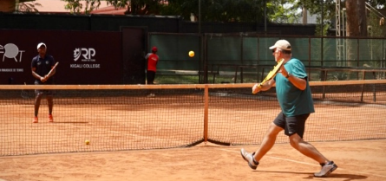

~~ Deadline: March 1, 2026 with $175 deposit paid to Christiane ~~
This early deadline is needed to commit to flights, court time and other logistics

Tour suggestions while in Rwanda
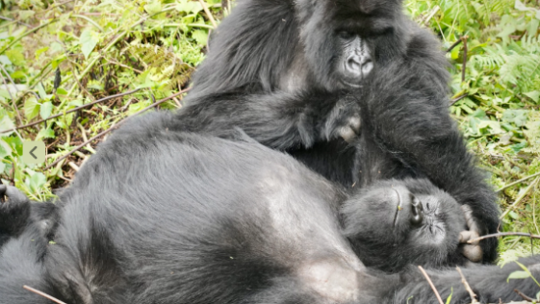
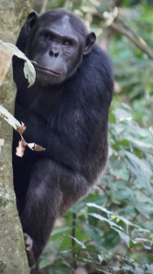
- Chimpanzees! Cyamudongo Forest in Nyungwe Forest National Park is about 6 hours from Kigali. Don’t miss the King’s Palace, Tea Tour and the Canopy walk!
- Gorillas! Volcanoes National Park is approximately 3 hours from Kigali, the Gorilla Permit is $1500, plus any transportation and tour expenses. Expensive, but worth it!
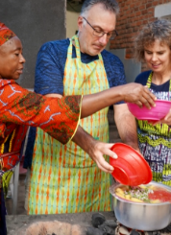
- Genocide memorials (Nyamata Genocide Memorial Site, Murambi Memorial Site, and countless others)
- King’s Palace, Ethnographic Museum
- Safari in Akagera or Tanzania
Kigali’s Optional Afternoon Excursions (extra cost)
Monday – Nyamirambo Women’s Center & Walking Tour
We will visit the Nyamirambo Women’s Center to browse locally made crafts while supporting community initiatives; get a shirt or dress made from their vibrant fabrics! Then explore shops, cafés, and daily life alongside a local guide.
Tuesday – Kigali Genocide Memorial & Peacekeepers Memorial
The Kigali Genocide Memorial – gain an important historical context and a deeper understanding of Rwanda’s past and recovery. We’ll also stop at the Belgian Peacekeepers Memorial to reflect on international involvement during the genocide.
Wednesday – Kimironko Market & Ntarama Church
Kimironko Market, Kigali’s largest and most colorful market, with time to explore produce stalls, fabrics, and local goods. Then continue to the Ntarama Church for one of the most powerful genocide memorials, preserving the site where thousands of people sought refuge and lost their lives in 1994.

Vamos! Get a glimpse of what to see and a link to more photos by Jason Benedict who was visited Rwanda and Tanzania this year and loved it.
For more information contact Jason Benedict; jason@thebenedicts.ca
He has many more photos and videos on his Facebook page; facebook.com/media/set/?set=a.10161185943720963&type=3, click Feed View for best viewing

Christiane (Chschunk@cs.com)

